

**Cloud Deployment Models**

**Name:** Pratham Kandari

**Sap Id:** 500097663

**Batch:** 7

**LAB- 3**

**Deploy a virtual machine instance**

Step 1) Login to your Openstack Dashboard.

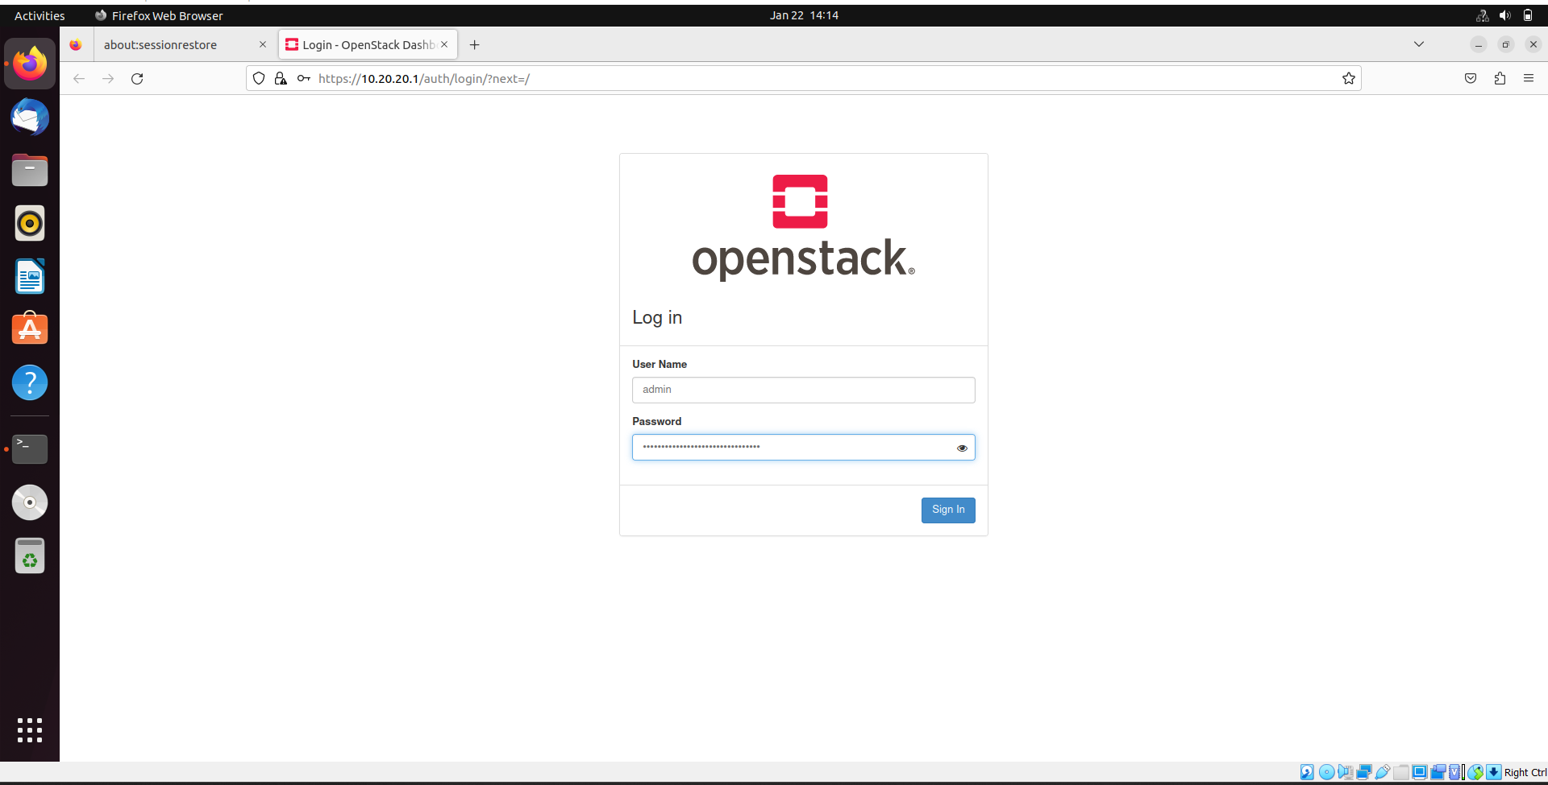

Step 2) Go to Compute -> Key pairs.

And create a Key pair, Give it a name and select Type -> SSH.

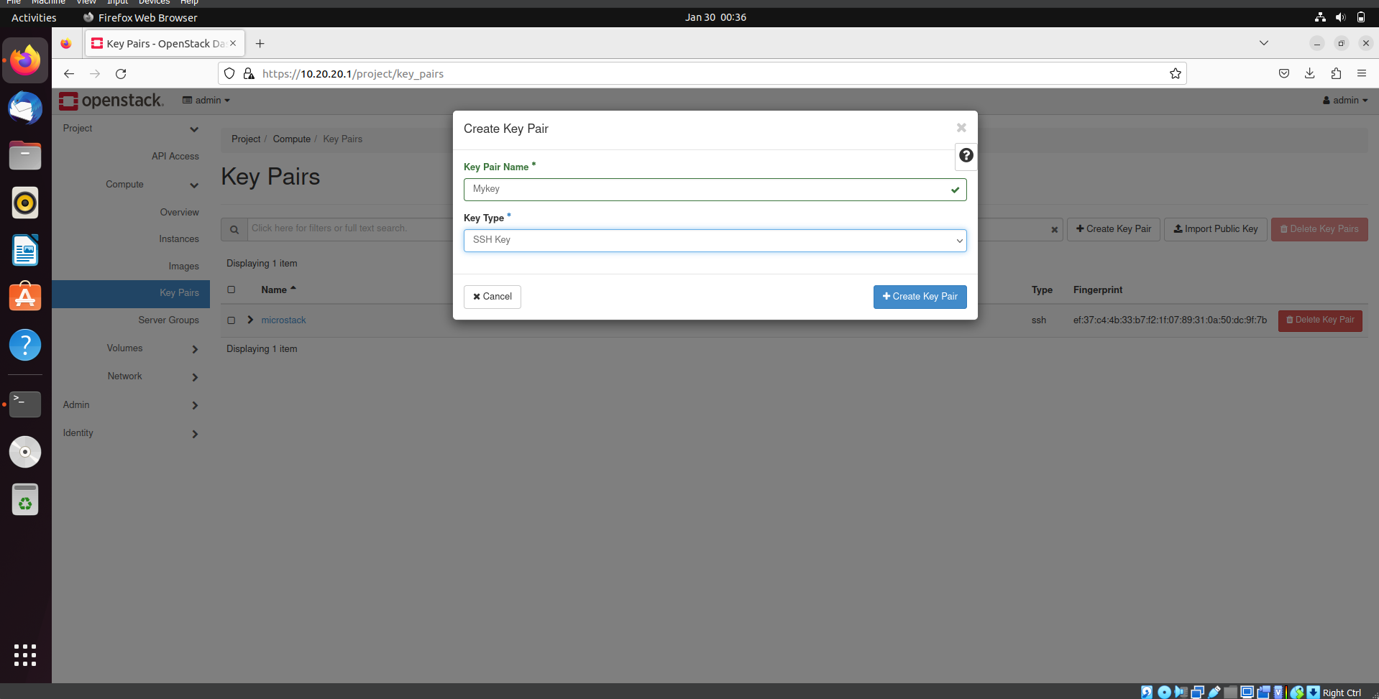

Step 3) A key pair will be created.

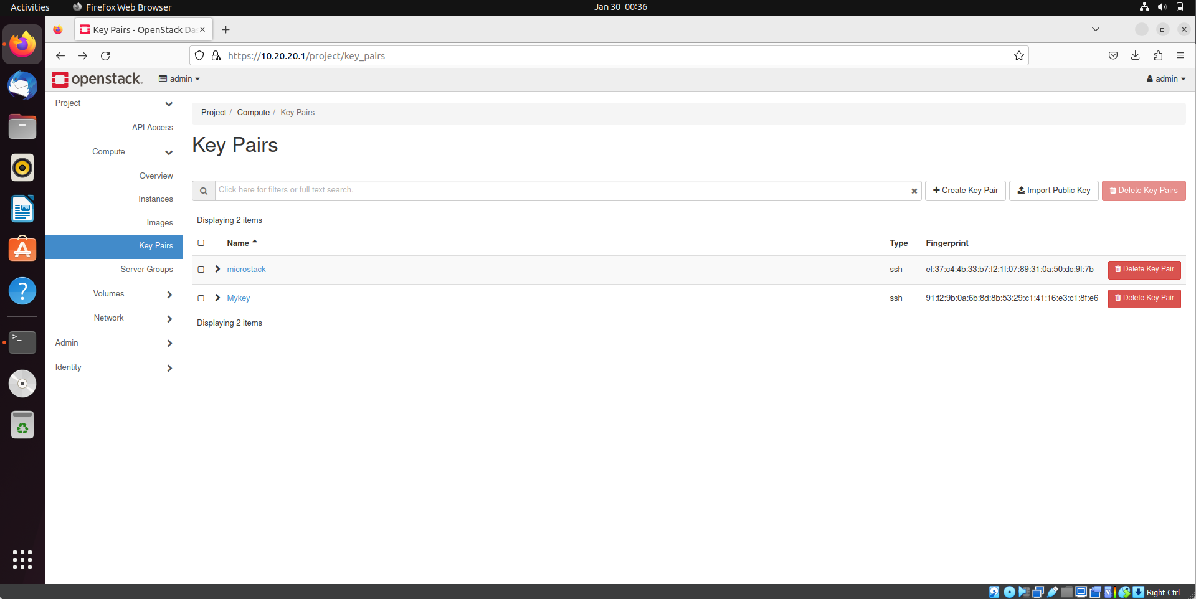

Step 4) Now go to Instances and click on Launch Instance.

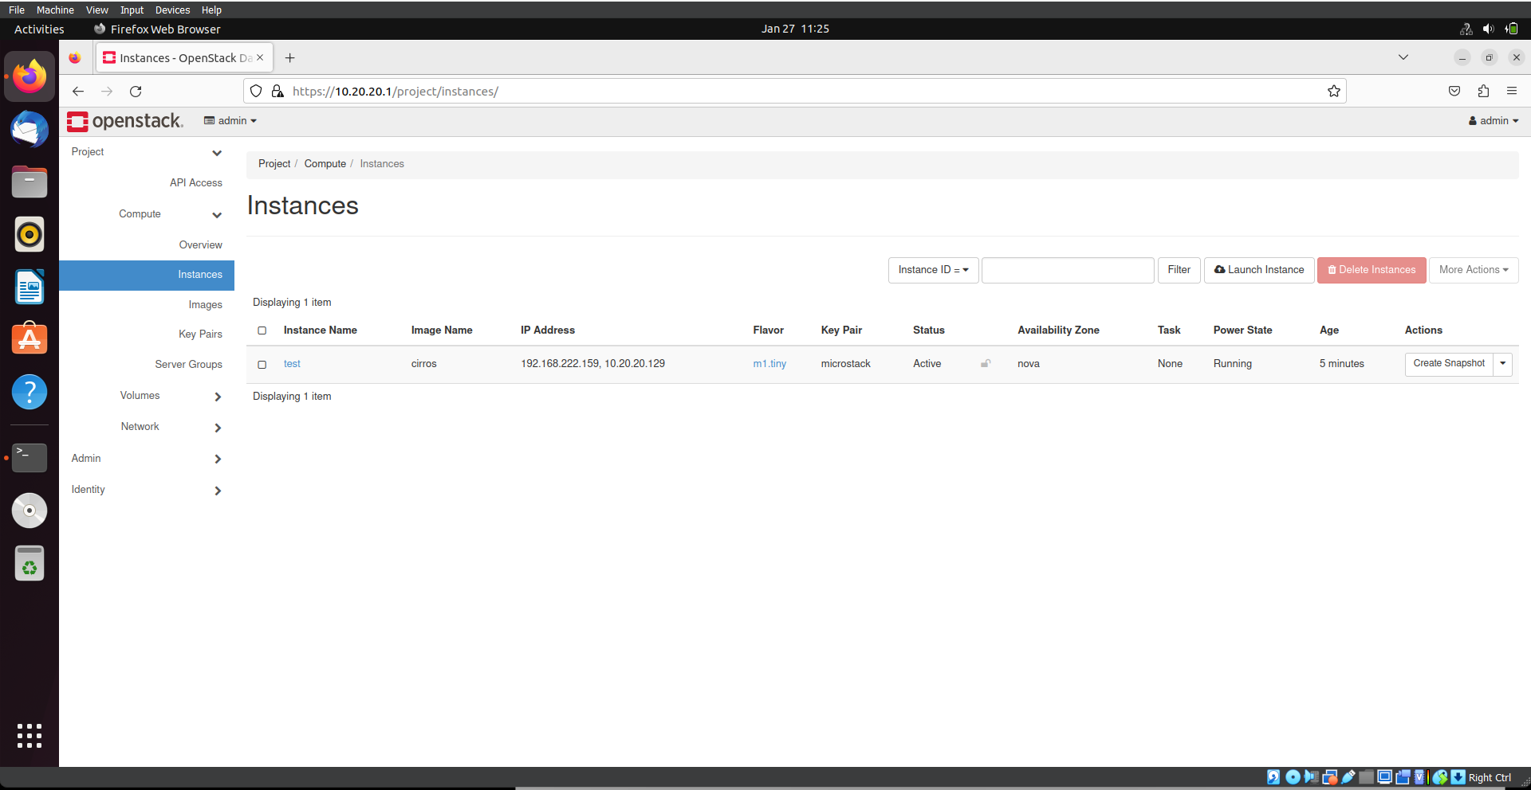

Step 5) Give it a Name, let availability zone -> Nova, and click on Next.

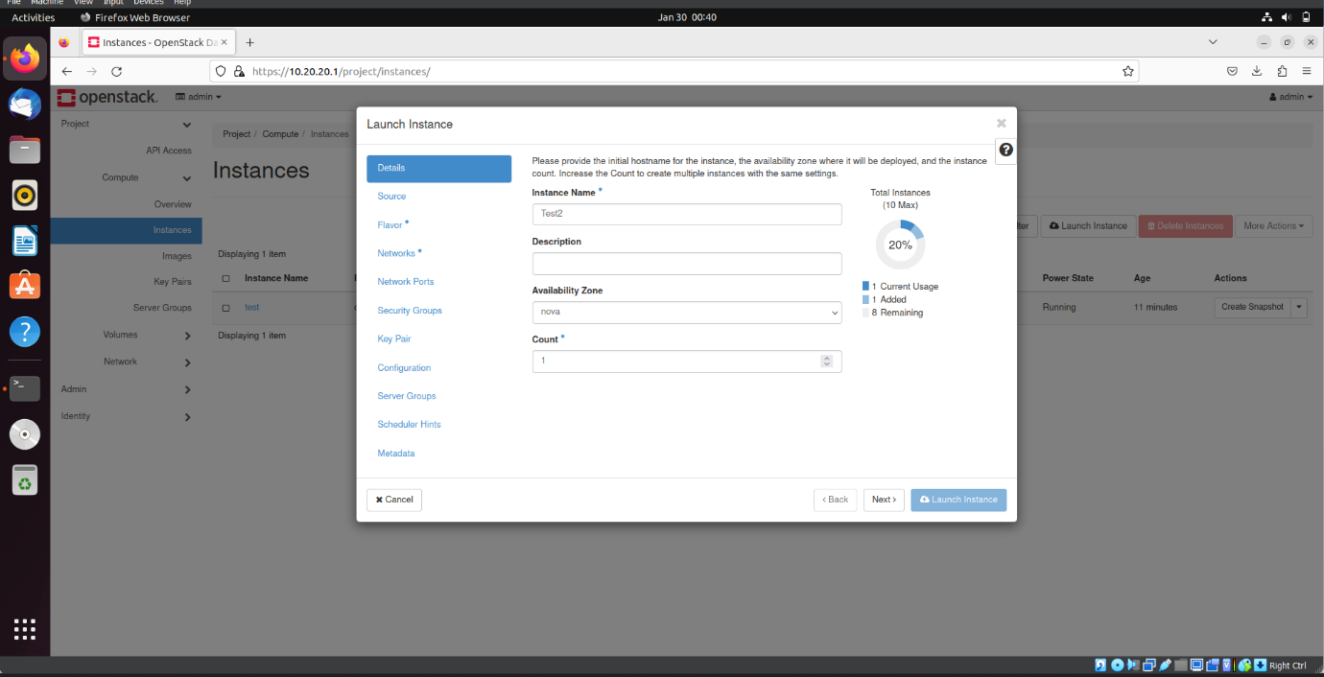

Step 6) Select Cirros OS from the available sources, and click on next.

CirrOS is a minimal Linux distribution that was designed for use as a test image on clouds such as OpenStack Compute.

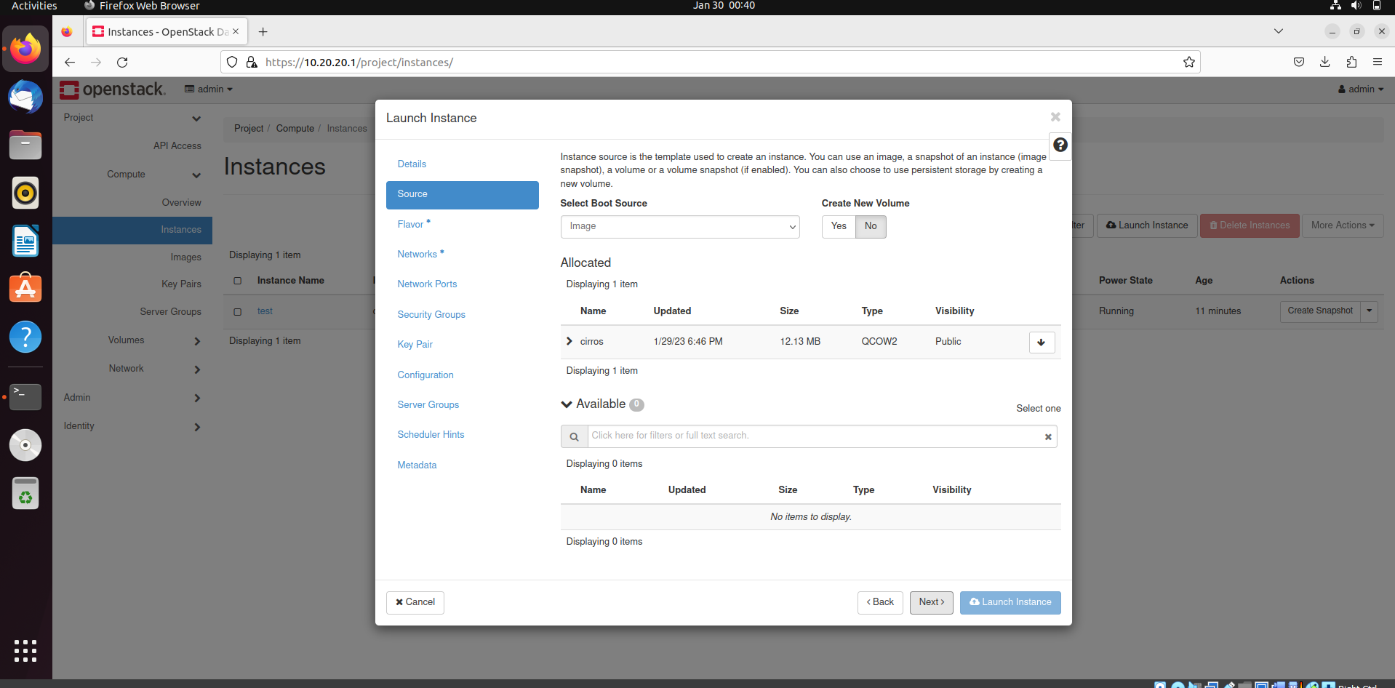

Step 7) Select a Flavor .

A **flavor** is an available hardware configuration for a server. It defines the size of a virtual server that can be launched.

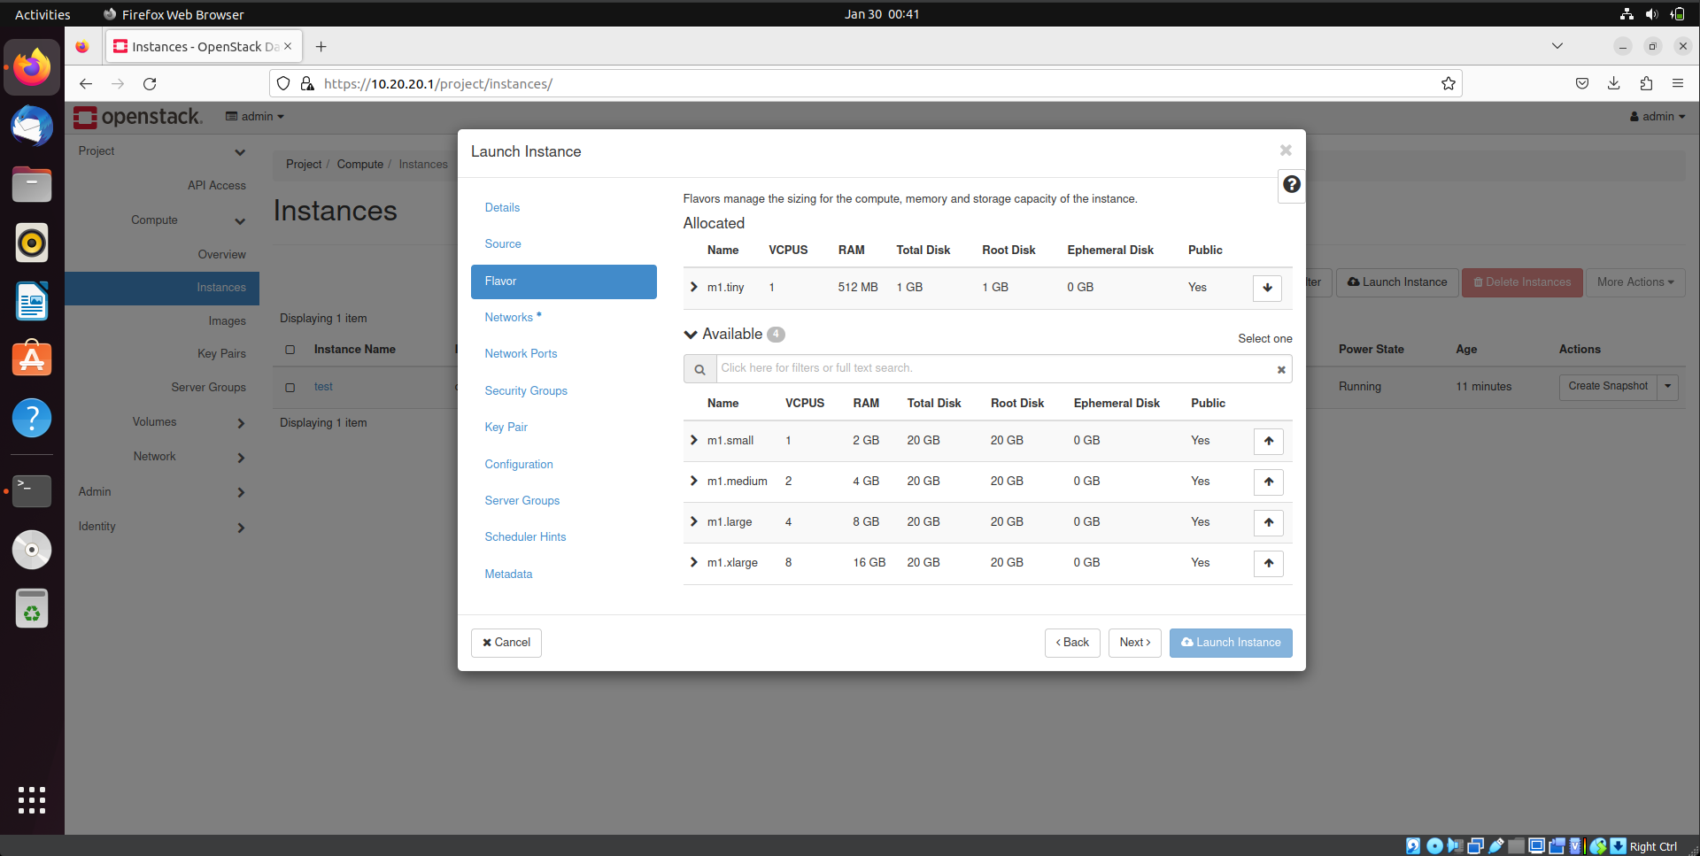

Step 8) Select both Networks available, and click on next.

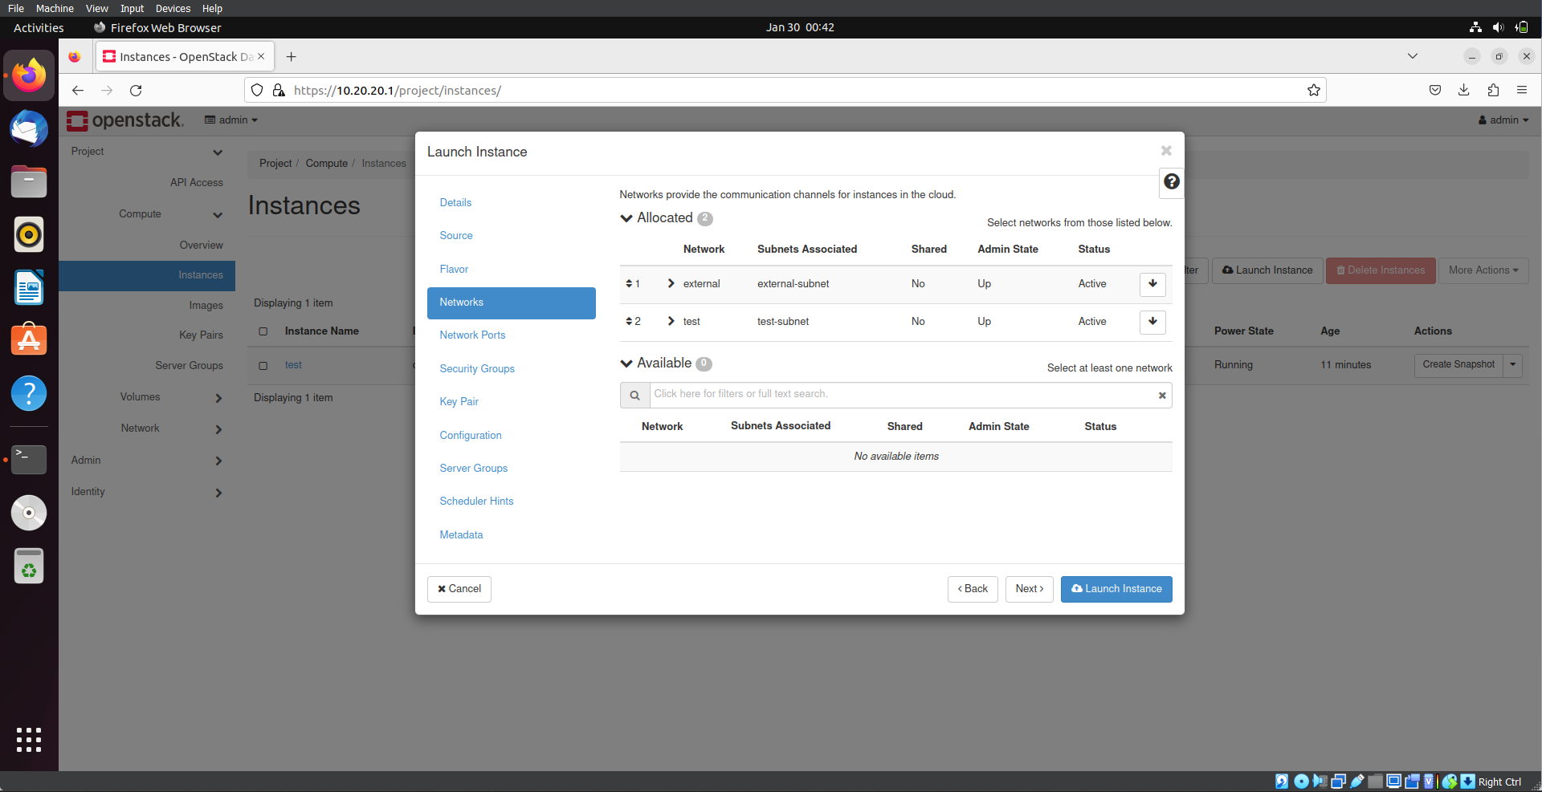

Step 9) Let network port be default, and click on next.

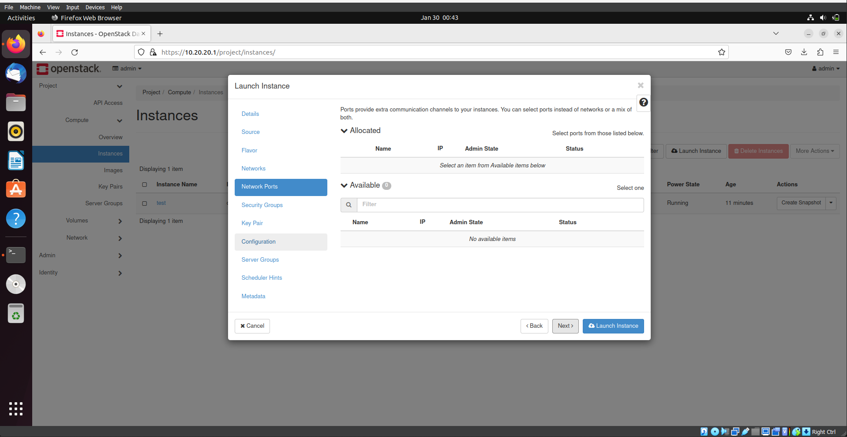

Step 10) Let security group be default, and click on next.

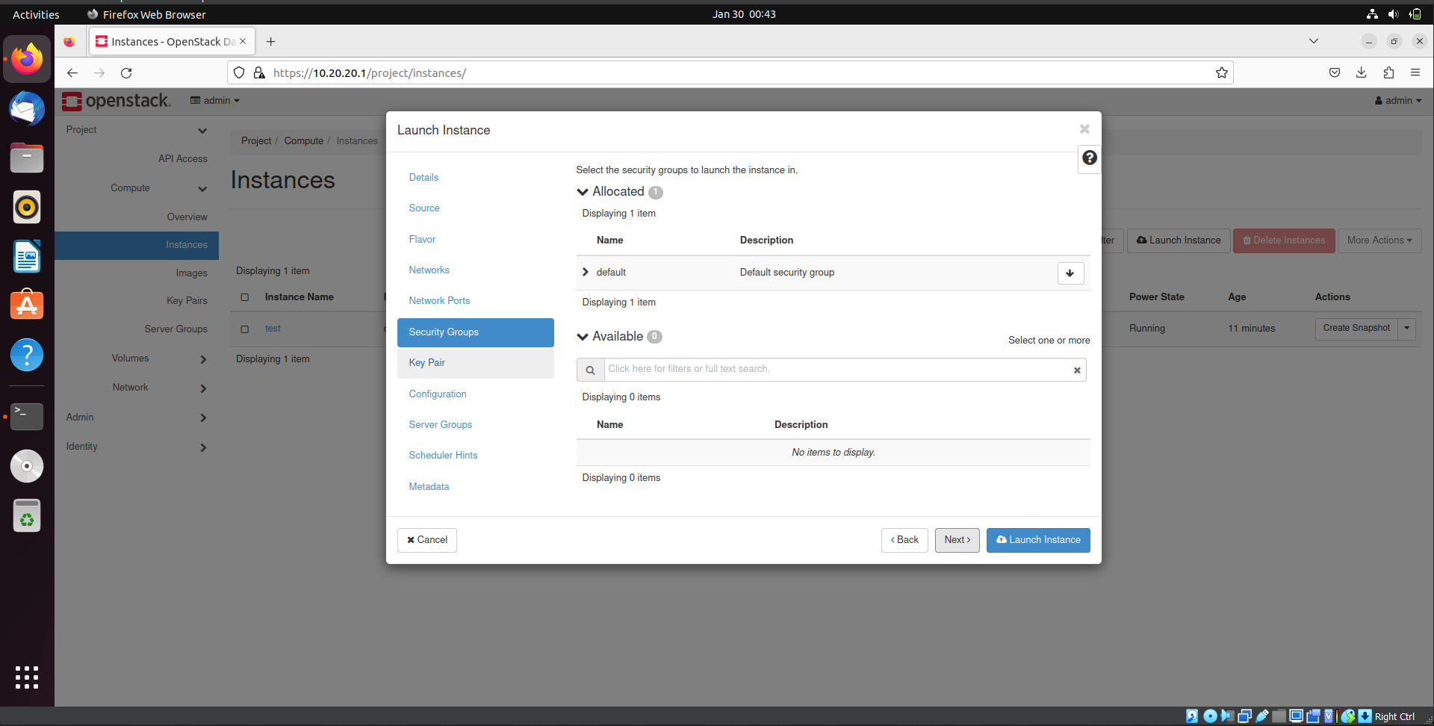

Step 11) In the key pair, select the key-pair we created, and click on launch instance.

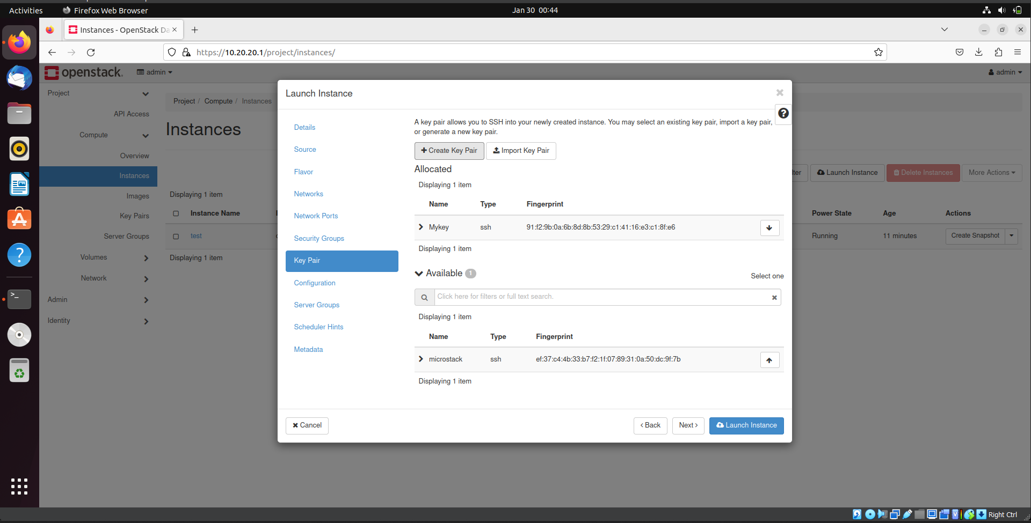

Step 12) An instance will be created, click on the instance.

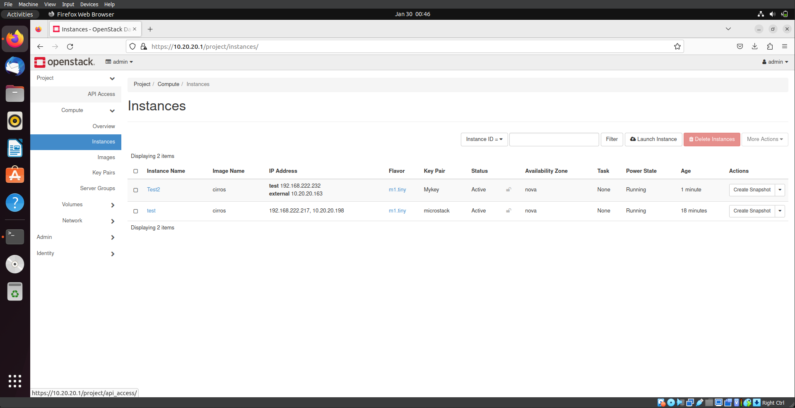

Step 13) Go to Console and open console.

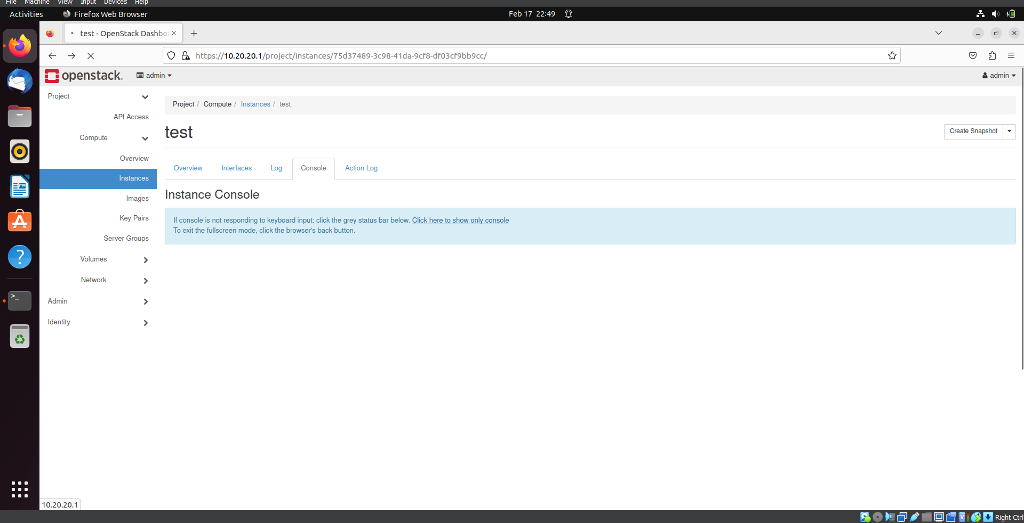

Step 14) A terminal of the instance will Open.

